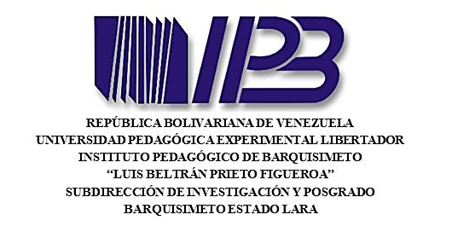
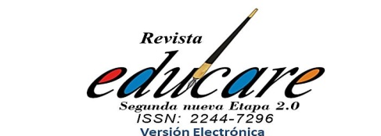

DECLARATION OF ORIGINALITY, TRANSFER OF RIGHTS
AND CURRICULUM SUMMARIES

The purpose of this document is to collect information on individual and collective contributions and their respective originality. Complete all the information. If any does not apply to your document, explicitly indicates that it does not apply, do not forget to include the signature of each author. You must not delete any section of this document when sending the information.

City: Name of the city, Date:Pick a date

Dear Members of the Editorial Board of the UPEL-IPB EDUCARE Journal:
Those of us who sign as authors of the: Pick your type of article... titled: Article title submitted for evaluation to the previously mentioned Journal, declare under oath that:
- The article is original and unpublished; it constitutes an intellectual production of the signatories and has not been publicly disclosed to third parties by any printed or digital means of diffusion.
- The article has not been simultaneously submitted for publication to another electronic printed journal or in any other written or electronic medium or publishing entity.
- The authors have not previously signed before third parties contracts for the transfer of patrimonial rights or licenses of use concerning the intellectual property rights that they hold on the postulated article that prevents them from assigning them employing this act to the UPEL-IPB EDUCARE Journal.
- They acknowledge that the Journal does not necessarily share the claims made in the article.
- It states that all the citation data within the text and their respective references have the source and credit duly identified following the rules of the APA citation standard.
- They provide the permits or authorizations of those who own the patrimonial rights for the use of tables and figures (illustrations, photographs, drawings, maps, diagrams, and other images) that are not of their creation or that do not belong to the researcher.
- If the article is accepted for publication, they allow the exclusive free transfer for an indefinite period of their patrimonial rights of authorship to the Universidad Pedagógica Experimental Libertador – Instituto Pedagógico de Barquisimeto, Venezuela (UPEL-IPB) that implies:
- The graphic and style edition of the work or part of it.
- Wording adjustment to incorporate inclusive and non-discriminatory language.
- The full publication and reproduction of the work or part of it, both by printed and electronic means, including the internet and any other known or unknown technology.
- The translation of any language or dialect of the whole article or part of it.
- The adaptation of the article to sound-voice reading formats and any other representation or technical mechanism available that makes it possible for people with some form of special abilities that prevent them from accessing the conventional reading of the article.
- The distribution and making available of the article to the public so that they can have access to it from the time and place that each person chooses through the available physical or electronic mechanisms.
- To distribute the article through the Creative Commons License. Non-commercial attribution, without derivative works, 3.0 which implies the possibility that readers can free download, store, copy and distribute the final approved and published information of the article as long as it is done without commercial purposes, to derivative works, to mention the source and authorship of the article or any other form of use, process or system is known or to be known that is related to the activities and editorial purposes to which the Journal is linked.
- Any other form of use, process, or system is known or to be known that is related to the activities and editorial purposes to which the Journal is associated.
- Reuse rights: The authors accept that the UPEL-IPB grants them the right to reuse for any purpose and to be able to publish the final approved and published version of the article on the internet or any electronic site, as long as the authorship of the text and its first place of publication is non-profit and no derivative works are issued.
- They consent to provide the journal with an email contact as well as the personal data necessary to identify the authorship of the article identified in this document for the respective publication.
- Once they authorize the Journal to publish together with the article their personal data, necessary to identify the authorship and affiliation, for example, name, surname, the institution of affiliation, City, country, mail, and ORCID number. Any other personal information other than those indicated above will be protected by the Journal, and may not be disclosed or transferred to third parties without the author's consent.
- They admit that the application and possible publication of the article in the Journal will be governed by the editorial policies of the institutional regulations of the Universidad Pedagógica Experimental Libertador – Instituto Pedagógico de Barquisimeto, and the legislation of the Bolivarian Republic of Venezuela, additionally that in the event of a difference in criteria or future dispute, it is will settle following alternative dispute resolution mechanisms and Venezuelan legislation.

DECLARATION OF AUTHORSHIP AND CONTRIBUTIONS

- In the case of articles elaborated in co-authorship, all the authors have read and approved the nominated manuscript and designate Name of designated co-author as the person in charge of receiving correspondence and with sufficient authority to represent other people if necessary:
- They accept that, with their cooperation, the article presented will be adjusted by the journal's editing board in agreement with the norms for authors (previously established and published on the official website of the journal); in terms of procedures, format, writing, correction, edition, translation, publication, duration of the historical process, and other requirements requested in said standards.

(Signatures on the next page…)

SIGNATURES:
(For the names use the following standard combination according to Educare’s protocols)
First Surname + Second Surname, First name + Second Name. Example: Pérez Rodriguez, María José
This is the order of appearance once the document is published.
Author 1
Surnames, Names  (As it will appear in the article) | Surnames, Names (author 1) | SIGNATURE  Click to insert the image of your signature or digital signature encoding here
The institution  (Complete name, not acronyms)Only one institution. Indicate independent professional if you do not declare an institution. | Institution (author 1) | 
City and country of the institution  Indicate the country’s residence if you do not declare an institution | City and country of ths institution (author 1)
Email  If you declare institutional mail, keep consistency with the institution and country declared. | Email (author 1)
ORCID identifier  This information will be necessary to publish. Copy from the website. | ORCID identifier (author 1)
Social networks  Twitter, Instagram, Facebook, Web page | Social networks (author 1)

(More authors on the next page…)

Author 2 (same indications apply as for author 1)
Surnames, Names | Surnames, Names (author 2) | SIGNATURE
The institution | Institution (author 2)
City and country of the institution | City and country of ths institution (author 2)
Email | Email (author 2)
ORCID identifier. | ORCID identifier (author 2)
Social networks | Social networks (author 2)

Author 3 (same indications apply as for author 1)
Surnames, Names | Surnames, Names (author 3) | SIGNATURE
The institution | Institution (author 3)
City and country of the institution | City and country of ths institution (author 3)
Email | Email (author 3)
ORCID identifier. | ORCID identifier (author 3)
Social networks | Social networks (author 3)

(More authors on the next page…)

Author 4 (same indications apply as for author 1)
Surnames, Names | Surnames, Names (author 4) | SIGNATURE
The institution | Institution (author 4)
City and country of the institution | City and country of ths institution (author 4)
Email | Email (author 4)
ORCID identifier. | ORCID identifier (author 4)
Social networks | Social networks (author 4)

Author 5 (same indications apply as for author 1)
Surnames, Names | Surnames, Names (author 5) | SIGNATURE
The institution | Institution (author 5)
City and country of the institution | City and country of ths institution (author 5)
Email | Email (author 5)
ORCID identifier. | ORCID identifier (author 5)
Social networks | Social networks (author 5)

